SANTA CECILIA SCHOOL

TECHNICAL BACCALUAREATE IN COMPUTING SYSTEMS



TECHNICAL SCIENTIFIC PROJECT 2020

SECTION:

Computing Systems & English freshman

MEMBERS:

Cartagena Marroquín, Gerardo Alfredo

Cuéllar Meléndez, Diego Roberto

Molina Mejia, Christian David

Vanegas Díaz, Christopher Ernesto

TEACHER:

Sinto Masín, José Félix

SANTA TECLA, AUGUST 2020

**Index.**

**INTRODUCTION---------------------------------------------------------------------3**

**OBJECTIVES ------------------------------------------------------------------------4**

**• GENERAL OBJECTIVE.**

**• SPECIFIC OBJECTIVE.**

**JUSTIFICATION ---------------------------------------------------------------------5**

**PROBLEM STATEMENT --------------------------------------------------------------6**

**PROJECT DESCRIPTION ------------------------------------------------------------7**

**HYPOTHESIS ----------------------------------------------------------------------16**

**LIMITING FACTORS ---------------------------------------------------------------17**

**CONCLUSION---------------------------------------------------------------------18**

**RECOMMENDATIONS ------------------------------------------------------------19**

**TIMETABLE ------------------------------------------------------------------------20**

**• Project Stages.**

**• First Stage Timetable.**

**• Second Stage Timetable.**

**• Third Stage Timetable.**

**BUDGET ---------------------------------------------------------------------------23**

**ACKNOWLEDGEMENTS ----------------------------------------------------------24**

**ANEXES---------------------------------------------------------------------------25**

**INTRODUCTION.**

The present project contains an explication about CATravels in detail and the steps to follow to create the web page.

In the general topic of the project explain what is the purpose of CAtravels and his target, followed by the problem statement, it is a part directed for the problem that the project is trying to solve, the justification is the answer of the question “for what?”

The objectives are different than the general topic, it includes specifically objectives of the project.

Initially the Technical, Technology and SCIENTIFIC FUNDAMENTS is a part of the project that the user can consult different definitions of the technical language that can result unfamiliar.

The way that use to organized the time is in base of a timetable, other table is the project resource, it has the items or human resource that use to carry out this project, it has a flowchart of the design and explication of any apart of the web page.

**OBJECTIVES**

GENERAL OBJECTIVE:

To develop a web page in where tourism services can be easier to be organized by the tourist to travel to different destination around Central America.

SPECIFIC OBJECTIVES

* To create different dynamics features to facilitate to the users their navigation experience on the web page interface.
* To design a special application for users to simulate a payment method that is required to confirm the payment of the trip in CATravels.

**JUSTIFICATION**

The execution of the previously described project is essential for the current problem that it is mention, due to the necessity of a trustable method for the people from any country of the world, who want to explore Central America.

With the issues and cons that Central America has, CATravels helps the user, promoves places and explains how can be explore in a way the users can do the trip and explore avoiding any delay in time or preventing waste of user money.

On the other hand, the project group has a mini-project, that is a fake credit card number generator, it is just an application to simulate a way to create a validate number for a "fake” payment when the user wants to confirm the transaction of “money” to the previously selected package or flight.

However, the project is an approximation of a real multinational enterprise network, the area where it is based the description is only Central America, because all the points, all the people, all the nations and the airlines; it is really too much for explore, so it is been decide to work only in the probably most unknown and forgettable part of the world, Central America; with nations probably that will never grow as their older brothers; because as other parts of the world, the people can see and experiment history, culture and religions.

To conclude, CATravels is oriented for all users who wants to travel in Central America finding precise information about every need of every traveler around the world to visit new places. To the clients or companies, they have the opportunity to spare their services and if it is a no-very popular service, the page will promote it more than the others, with a very low quote, the page will provide with flexible rules a way to interact to be better and have an opportunity to get known by the travelers.

**PROBLEM STATEMENT**

The problem that the project solved it is the need of a complete web page, made exactly for the necessity of the people that travel around the world, more precisely to explore the locations around Central America; with all the opportunities that the web page offers the user can always have a place to visit.

Also, the project solved a very important problem, it is the waste of time and money; with a simple but efficient way to login, research and pay easily in 15 min the user could finished planning the vacations.

In addition, the project was also made for the companies that want to promote their services, meaning, the regular hosting packages and the airlines flights; being absolutely flexible with rules, CATravels is friendly with any kind of services of any place in Central America.

Finally, when the user is going to confirm the payment of the trip, a payment method requests a credit card number; to avoid any problem, a desktop application it was made to create an acceptable credit card number to simplify the process of payment to the company.

**PROJECT STEPS DESCRIPTION**

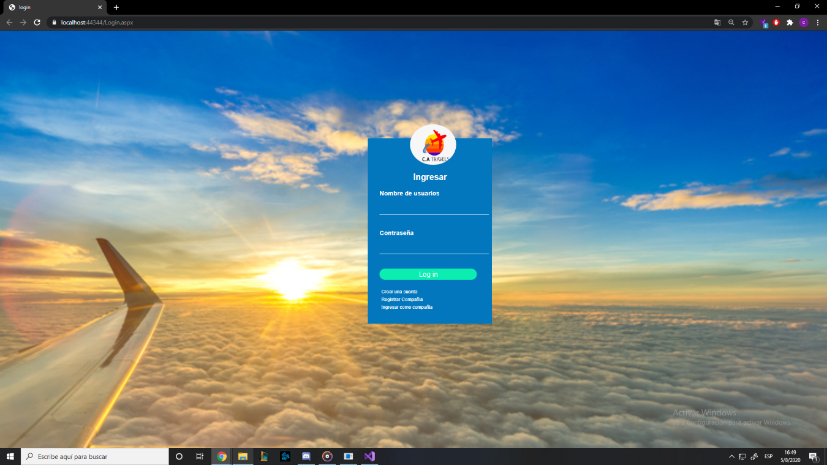

To create the login, first the front-end had to be developed using HTML and CSS, this was programmed in the ATOM application, then it was transferred to visual studio to change the buttons and texts to the C # language so that it could be programmed in a correct way.

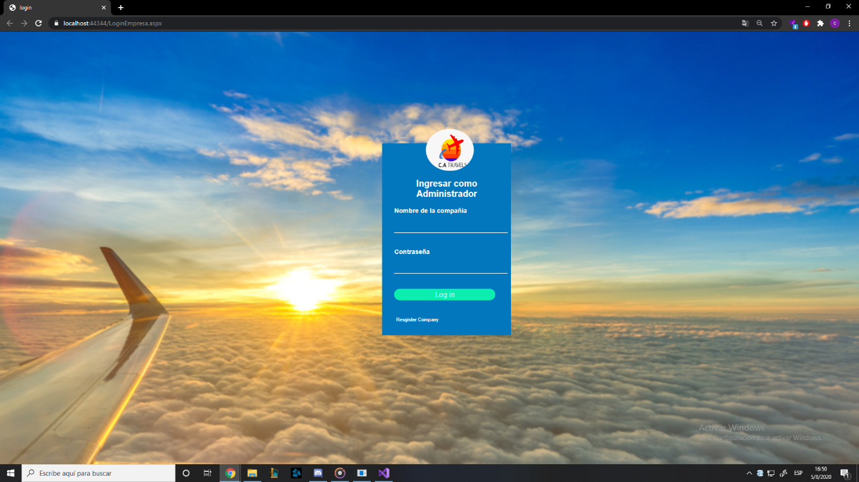

To create the administrator login or rather the customer login, it was necessary to base ourselves on the customer login as it is quite similar but to validate the user names and passwords, two different classes had to be created for each login as it was different table information different from the database, after having created the two classes it was possible to enter the page correctly but there was still no record.

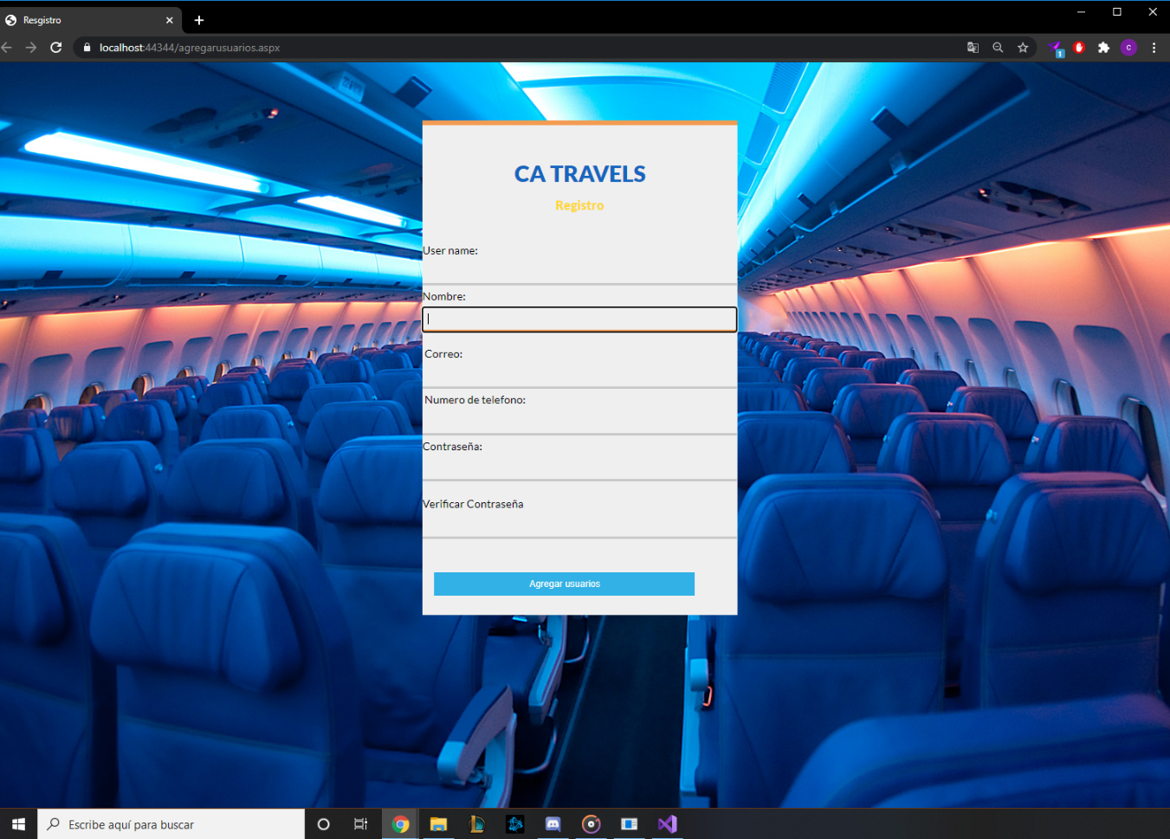

After creating the login of clients and users, the registry for the users was created, all the design parts were developed in applications other than visual but later they were implemented in visual studio, and the registry is not the exception as it was developed in the application ATOM, after including it in the visual study, a class had to be developed to control the storage in the database, in this way it is controlled what is going to be stored and in which part of the Database will be saved.

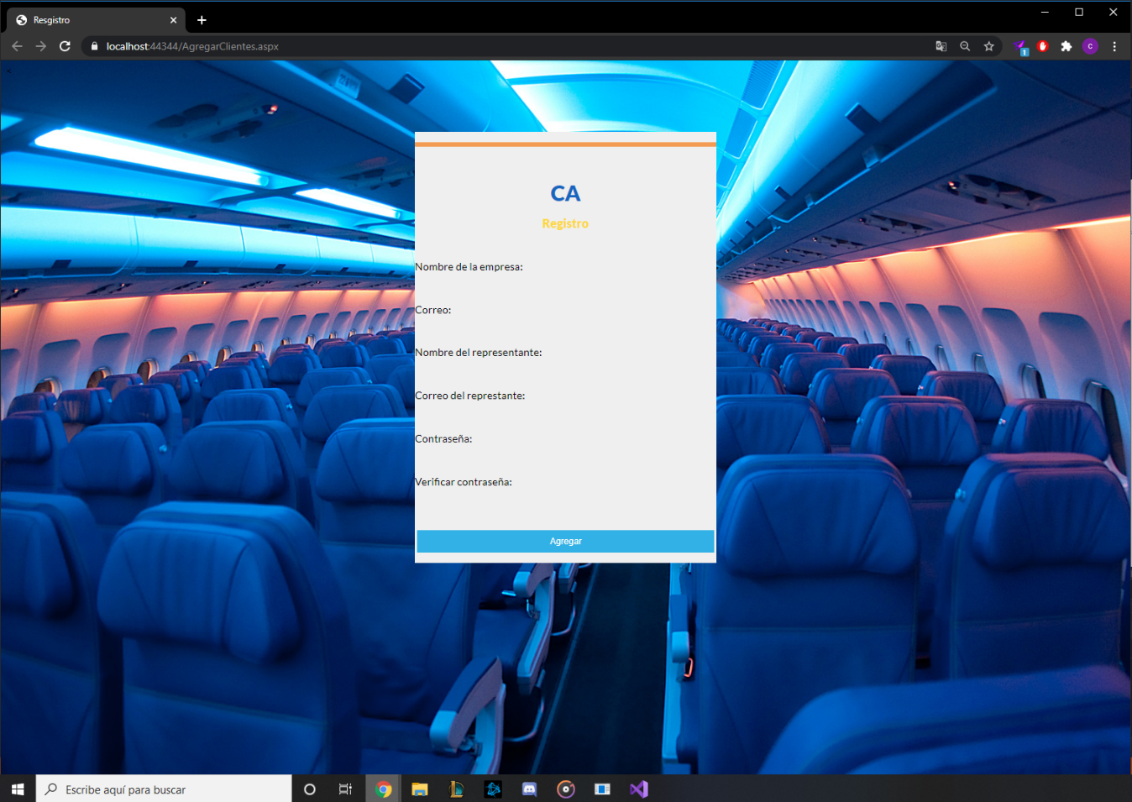

To create the company registry, a few more composes were created to fill out, as it had to be more extensive and the connection to the database changed because if it is the same database but it is another table, after this each field was used to that could not be left unfilled and the design part was worked in the ATOM application to later be implemented in visual studio.

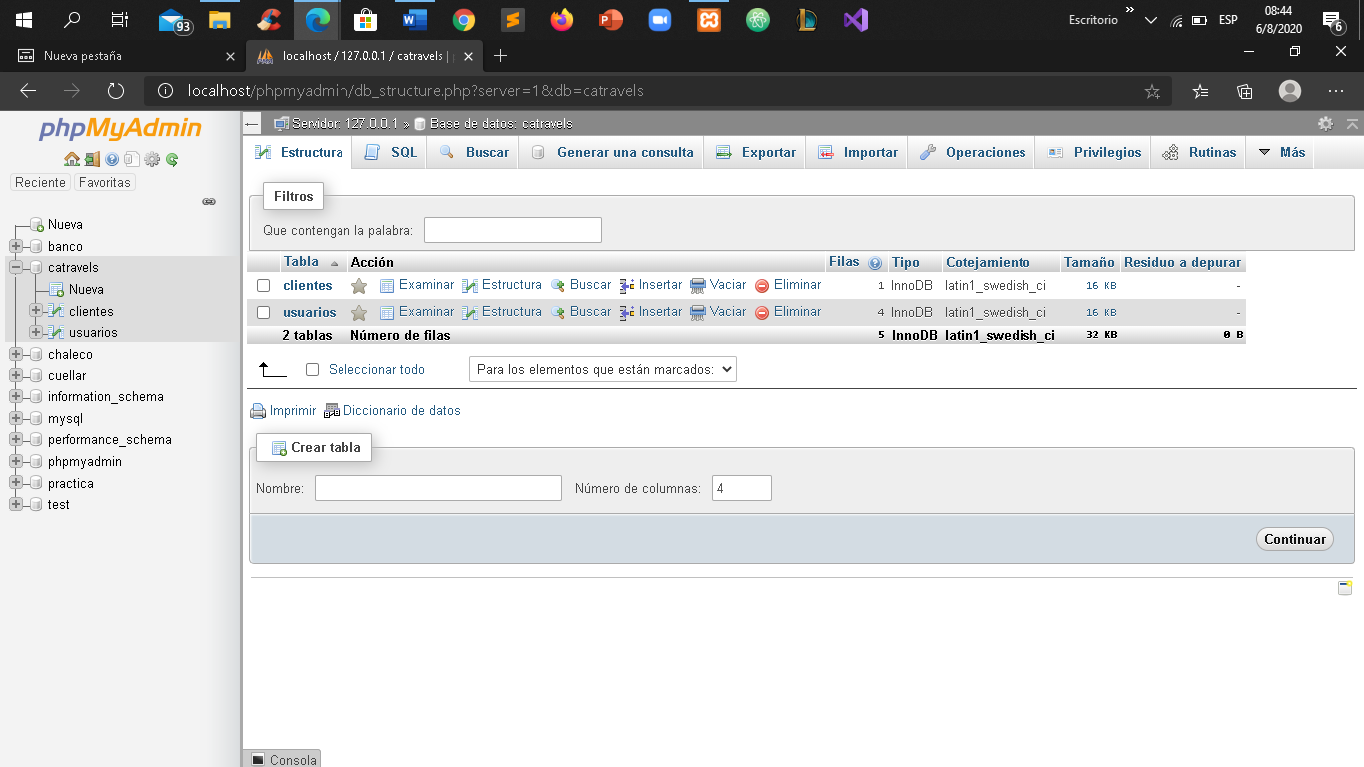

For the development of the database phpMyAdmin was use and create a database called "catravels" in which we implement two tables of clients and users, these for the storage of people and companies that register.

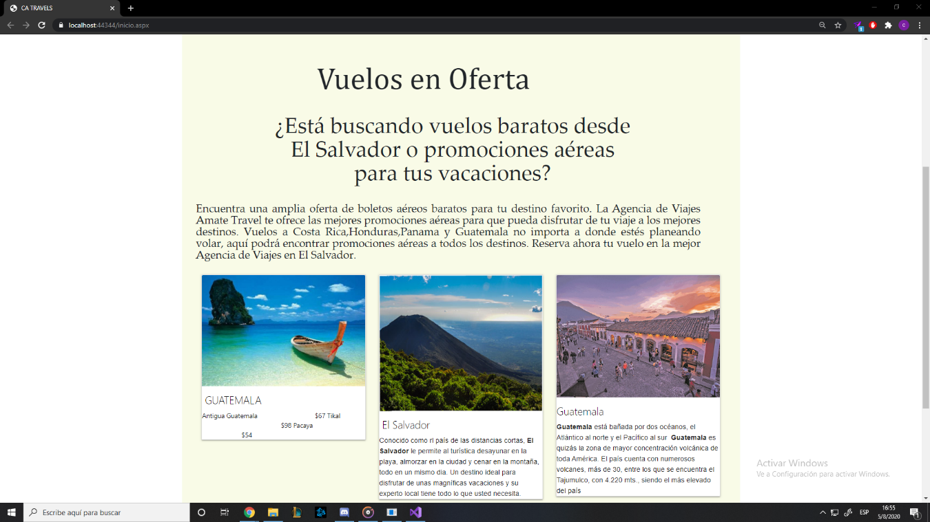

After creating the registration and login part, the home page of the page was developed, which the design was developed in the Dreamweaver application, which is a tool that worked quite well for us and the whole part of the design from the page of Start was developed in this application, later develop the design and implement it in Visual studio objects were changed to go from an html form to a web form.

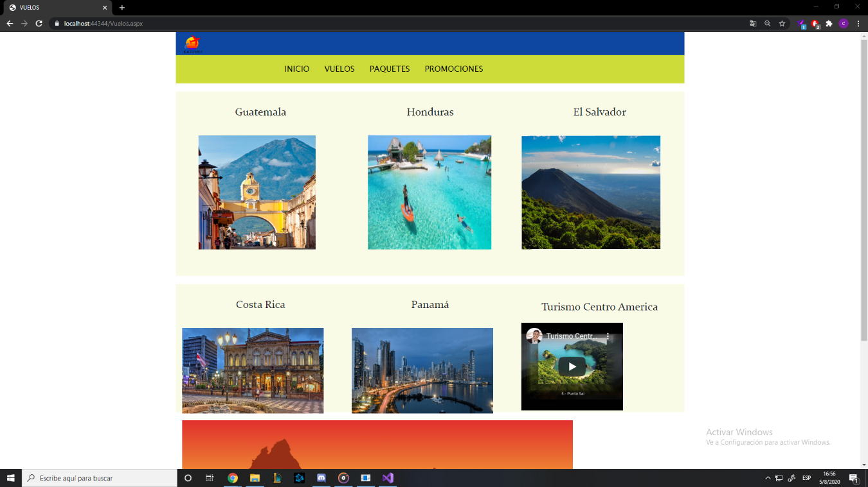

For the development of the flight page, we investigated places in Central American countries, from that we created the design, then we implemented it in visual studio and changed the elements to elements of the web form.

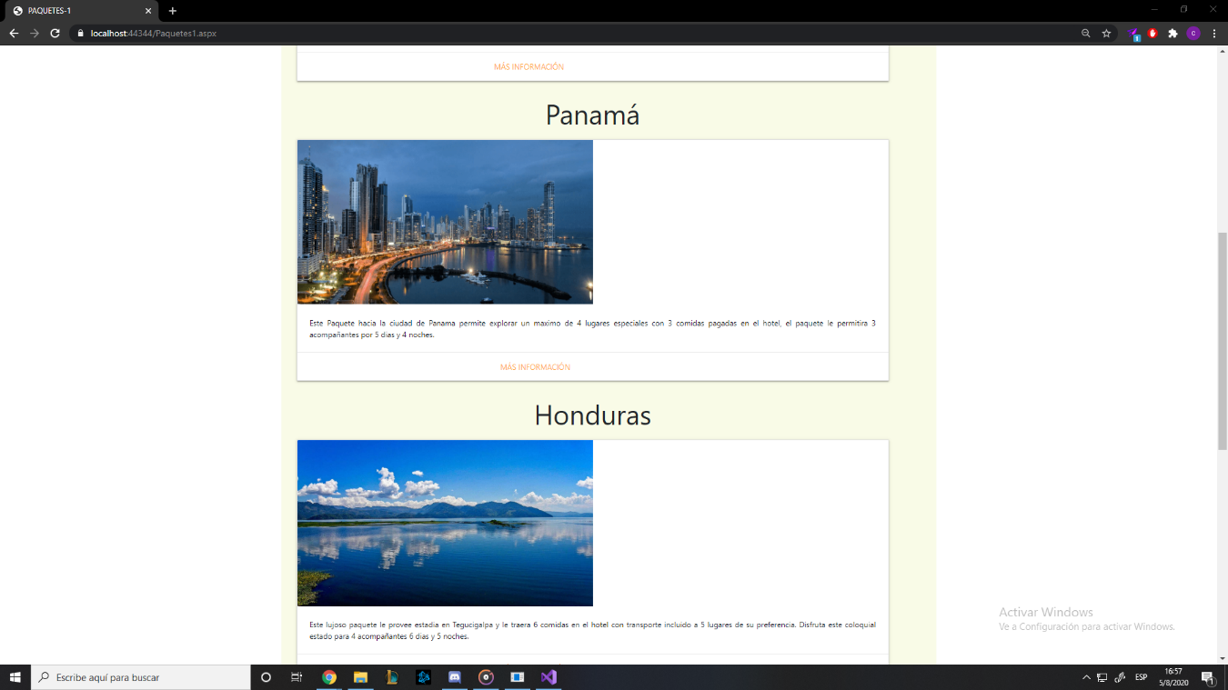

To develop the packages part, the companies that register will provide the packages they offer for different parts of Central America, the design of this part of the site was developed in Dreamweaver all the elements were changed so that it can be modified depending on the packages that the companies offer.

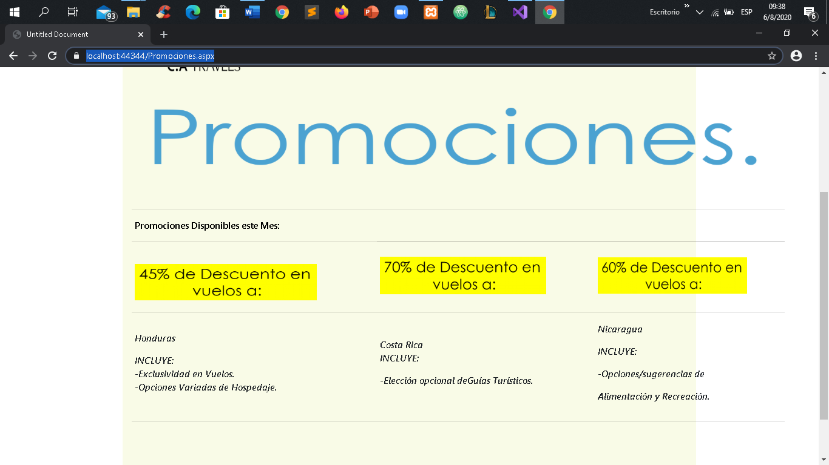

To develop this last part the same application for the design was used, the promotions that appear will be those that the company decides to put, or depending on which they have, to create the design Dreamweaver was used to later implement it in asp.net after this we create a connection to the database to collect promotions depending on the company.

**HYPOTHESIS.**

What led us to create a page of flight services in Central America was the lack of pages that would show the beauty of the Central American countries, since in many of these they only show the flight, the price and the duration, but they do not show photos of Central America, because of all this is that we saw the possibility of creating a travel page in Central America where people choose their packages or flights to visit beautiful places in Central America.

the project can be applied at a formal level and be an official website, but this requires more work since at the moment it is not a viable option to be an official site, but if you continue working on this project you could achieve a website functional.

With the project we seek to highlight Central America and show the multiple places that exist in Central America, the advantage that our project has or that it could reach is having a reliable web page in which users can see the trips in Central America that they want and for the industry, a place in which to upload their tourist places to make themselves known in central America and the world, also the travel agencies that need to promote their trips to different points may do so on the website, so if work on a larger scale can create a page for the benefit of both people and industries at the Central American level.

**LIMITING FACTORS.**

Electronic equipment that was used to create the Project are not in conditions to program:

Is a reality that do not live in a first world country so does not have the gamma and the money to buy a computer in conditions.

Time to create a really program with all those functions It should be created in long periods of time Experience:

In this case do not have the time as can be years, only had a few months.

The experience of the team that have the responsibility of develop the web page do not has the preparation to program as a professional:

The developers of the project just have basic preparation, and this is the first project that develop for the public.

**CONCLUSIONS**

In conclusion CaTravels is a website that in the long term would offer a higher quality travel service to its users, as well as provide the opportunity to grow any type of company that decides to register.

Companies can offer their services on our website, whether hosting, restaurants, and many others.

Also, at project level the simulation of a bank was created, the objective of this is to provide a user and a card number to people, to simulate payments on the main website.

**RECOMMENDATIONS.**

If you want to improve our project or create a project like the one, we have developed, consider some recommendations.

To create an Asian project you have to take into account that a language must be used to make the design, such as HTML, CSS or bootstrap, these can be programmed directly in ASP.NET but the best option is to have a text editor like They can be ATOM, Sublime text or the one that was used to develop the design of the project that is Dreamweaver is a fairly complete application and not so difficult to use.

On the other hand, you must know about databases, either phpMyAdmin or SQL server, the latter is more compatible with ASP. NET but PhpMyAdmin is lighter and less complicated to use, either way you can work with both, but knowledge about database managers is necessary.

To finish, you must know the programming language to use and have a minimum knowledge of other programming languages, such as JavaScript, this to create some type of validation in the front-end of the web page. Along with this one must be very organized when creating the project.

**TIMETABLE.**

Project Stages.

|  |  |  |
| --- | --- | --- |
| Stage. | Stage Name. | Period. |
| l | Projects Definition. | l |
| ll | Projects Design. | ll |
| lll | Projects Execution. | lll |

First Stage Timetable.

|  |  |  |  |  |  |  |  |  |  |  |
| --- | --- | --- | --- | --- | --- | --- | --- | --- | --- | --- |
| Stage | Activity | Weeks Of The Period | | | | | | | | |
| January | | | February | | | March | | |
| 14-18 | 21-25 | 28-31 | 1-8 | 9-20 | 21-29 | 1-9 | 10-19 | 20-31 |
| l | First Project Presentation |  |  |  | **x** |  |  |  |  |  |
| Second Project Presentation |  |  |  |  | **x** |  |  |  |  |
| Third Project Presentation |  |  |  |  |  |  |  | **x** |  |

Second Stage Timetable.

|  |  |  |  |  |  |  |  |  |  |  |
| --- | --- | --- | --- | --- | --- | --- | --- | --- | --- | --- |
| Stage | Activity | Weeks Of The Period | | | | | | | | |
| April | | | May | | | June | | |
| 1-9 | 10-19 | 20-30 | 1-9 | 10-20 | 21-30 | 1-9 | 10-19 | 20-31 |
| ll | Group Meeting |  | **x** |  |  |  |  |  |  |  |
|  | | | | | | | | | |

Third Stage Timetable

|  |  |  |  |  |  |  |  |  |  |  |
| --- | --- | --- | --- | --- | --- | --- | --- | --- | --- | --- |
| Stage | Activity | Weeks Of The Period | | | | | | | | |
| June | | | July | | | August | | |
| 1-18 | 21-25 | 28-30 | 1-8 | 9-20 | 21-31 | 1-9 | 10-19 | 20-31 |
| lll | PTC Vocational Week |  |  | **x** | **x** |  |  |  |  |  |
| Second PTC Vocational Week |  |  |  |  |  | **x** |  |  |  |
| Project Exposition on SDJ |  |  |  |  |  |  |  |  | **x** |
| Progress presentation |  |  |  |  |  | **X** |  |  |  |
| Final report presentation |  |  |  |  |  |  |  | **X** |  |
| Presentation of the full project |  |  |  |  |  |  |  |  | **X** |

BUDGET.

|  |  |  |  |
| --- | --- | --- | --- |
| N° | DESCRIPTION | QUANTITY | PRICE |
| 1 | Desktop | 1 | $925.50 |
| 2 | Notebook computer DELL | 1 | $450.00 |
| 3 | iMAC late 2013 | 1 | $1.300 |
| 4 | Monitor BENQ | 1 | $115.00 |
| 5 | Keyboard razer blackwidow | 1 | $90.00 |
| 6 | Visual studio | 1 | free |
| 7 | Notebook computer HP | 1 | $500.00 |
| 8 | Mouse logitech | 1 | $35.00 |
| Total: | | 8 | $12,415.50 |

**ACKNOWLEDGEMENTS**

Thanks to the teachers: Felix Masín and Emmanuel Posada, who with their knowledge and support guided us through each of the stages of this project to achieve the results that were sought.

Thanks to Santa Cecilia Salesian School for providing all the resources and tools that were needed to carry out the beginning of the creation process.

Finally, we thank all the developers involved in this project for carrying it out and their families for the support provided

**ANNEXES.**

**CATravels**

**Index**

**INTRODUCTION ------------------------------------------------ page 3**

**REQUIREMENTS ------------------------------------------------- page 4**

**Main Page ----------------------------------------------------- page 5**

**Creating an Account ----------------------------------------- page 6**

**After Creating an Account ----------------------------------- page 7**

**Navbar --------------------------------------------------------- page 8**

**Flights, part 1 --------------------------------------------------- page 9**

**Flights, part 2 –------------------------------------------------ page 10**

**Promotions part 1 –------------------------------------------- page 11**

**Promotions part 2, payment -------------------------------– page 12**

**Package part 1 –--------------------------------------------- page 13**

**Package part 2, Specific Information –--------------------- page 14**

**INTRODUCTION**

The purpose of the user manual is to make the CATravels website structure fully explain in this document with images and detailed information; made for any user without complex instructions or training, with only 4 simple steps to fully plan a trip to Central America.

**REQUIREMENTS**

Requirements of the web page:

1. The website is designed for the following browsers:

* Internet Explorer.
* Mozilla Firefox.
* Google Chrome.

1. The resolution of the screen required is a maximum of 1920x1080.

**Main page:**

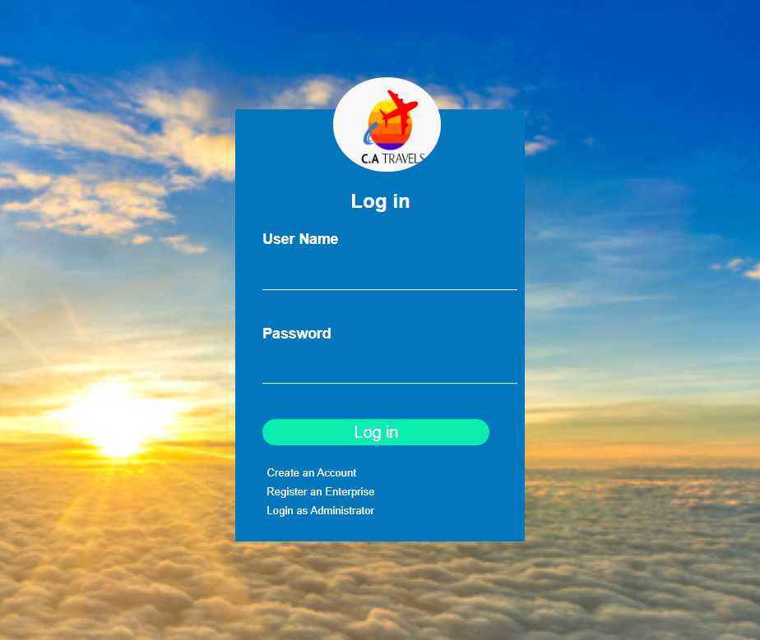The user must enter this web address: catravels.com ; in the selected browser in order to enter to the login page.

In this section of the page the user decides what to do next depending if the user has ever entered before or if the user is actually an interested Client.

**Create an Account**

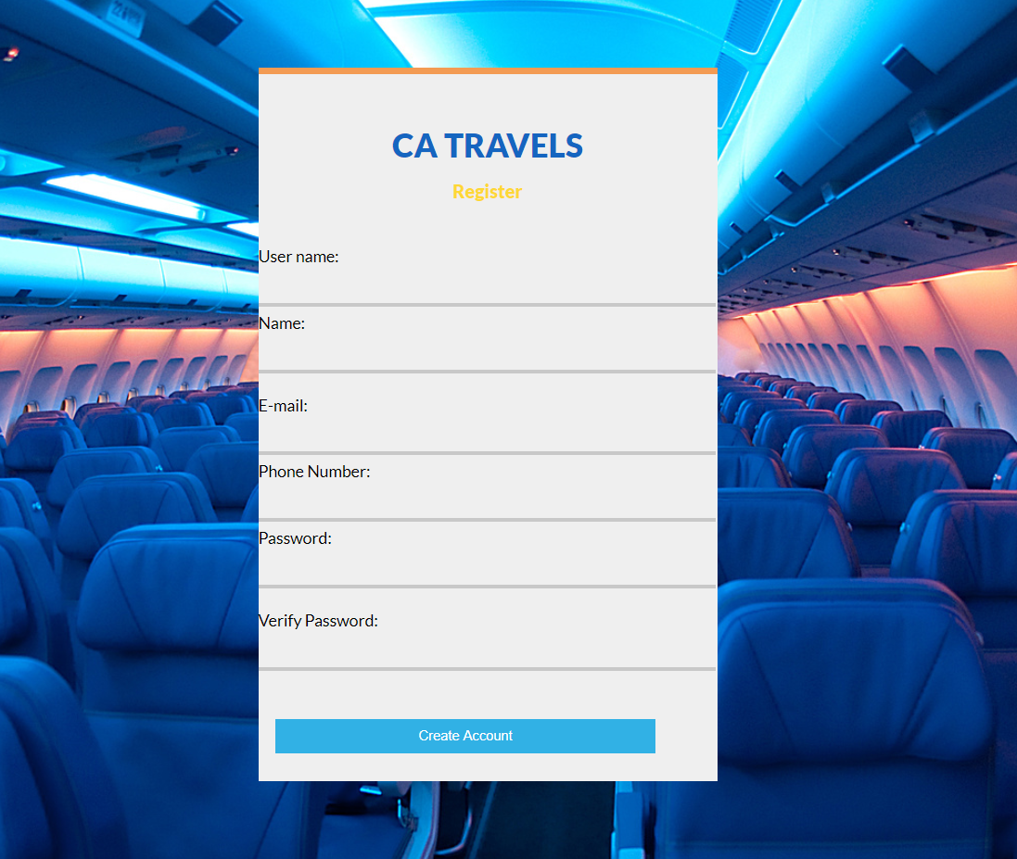

1. **User name:** Inside this field the user must insert his/her name that will be use in the website.
2. **Name:** In this field the user must place his/her complete name.
3. **E-mail:** In this field, the user must enter the email address they want to have registered.
4. **Phone number:**  Inside this field, the user will enter his/her phone number.
5. **Password:** In this field, a password must be inserted by the user to protect his/her account
6. **Verify Password:** In this field the user will re-enter the password to confirm it as your password.

**After creating an account:**

The user is now allowed to be redirected to a main page, where they will get some general information about the current offers and the deals or options for vacations trips.

**Inside the platform:**

Inside the home page, four options can bee seen, these navigation buttons are to divide the website in 4 main stages: home, flights, promotions and packages, once the user choose one option, it will be redirected to there.

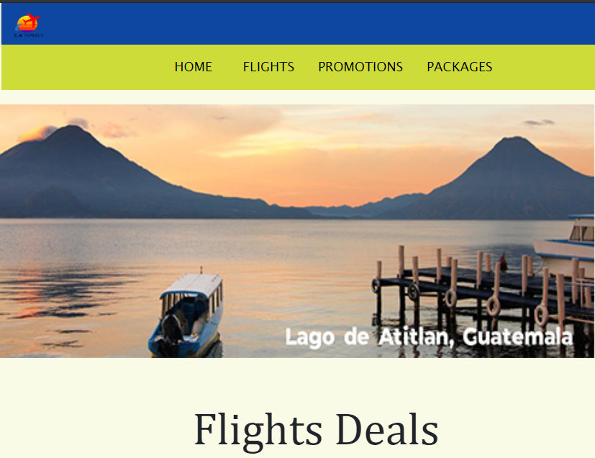In the rest of the main page “home”, is about the flights that are cheaper or it is shown the best deals.

**Information**

**Image**

**Navbar**

**Navbar:**

These options are just to allow the user to move quickly and easily through the 4 main options of the webpage to navigate in

**PROMOTIONS**



**PACKAGES**

**FLIGHTS**

1. **Flights:** a list of options about available flights to certain airports of Central America.
2. **Promotions:** options shown to information the user about what airlines flights have discount.
3. **Packages:** list of previously selected options with special offers, however not always will be viable options to pay for.

**Flights, part 1**

**Countries Available**

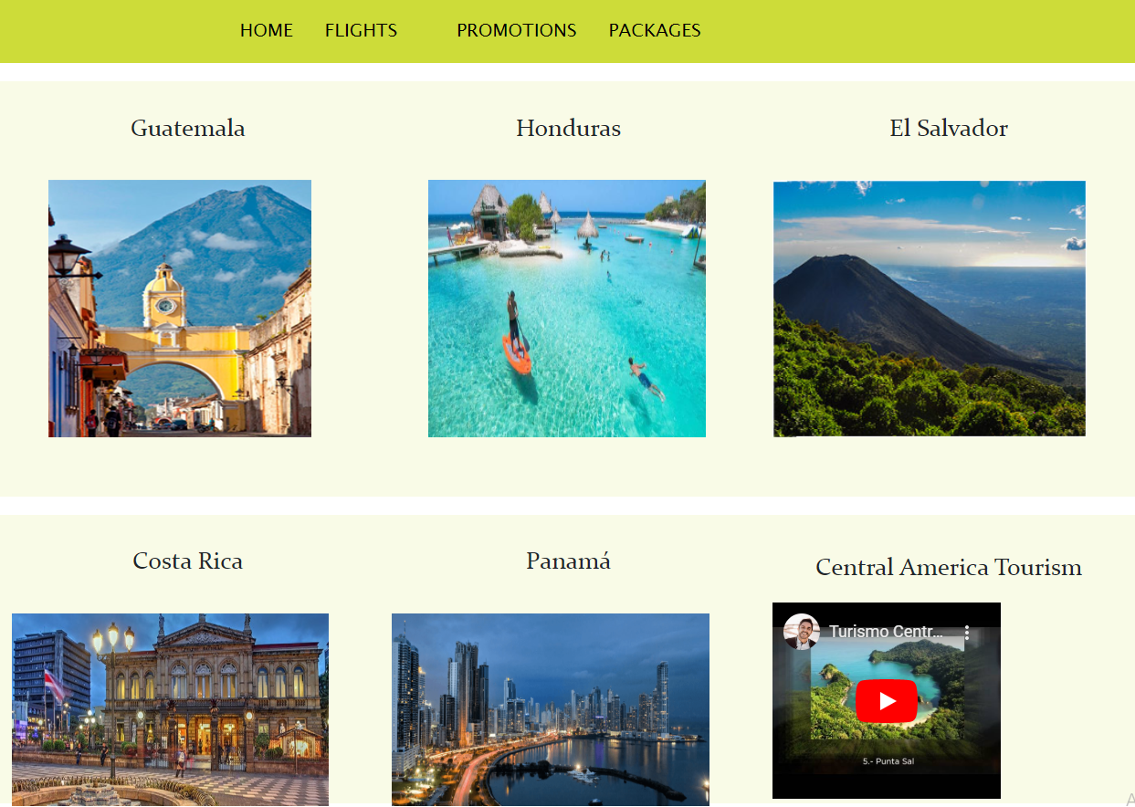

**Explanatory Video**

1. **Available Countries:** by this following five available countries to be visited using the website, the user can choose one by clicking in the image to be redirected in a formulary, after filling it, CATravels will provide the user final information about the flight it was found.
2. **Explanatory Video:** the video has the purpose to motivate the user to make the final decision.

**Flights, part 2**

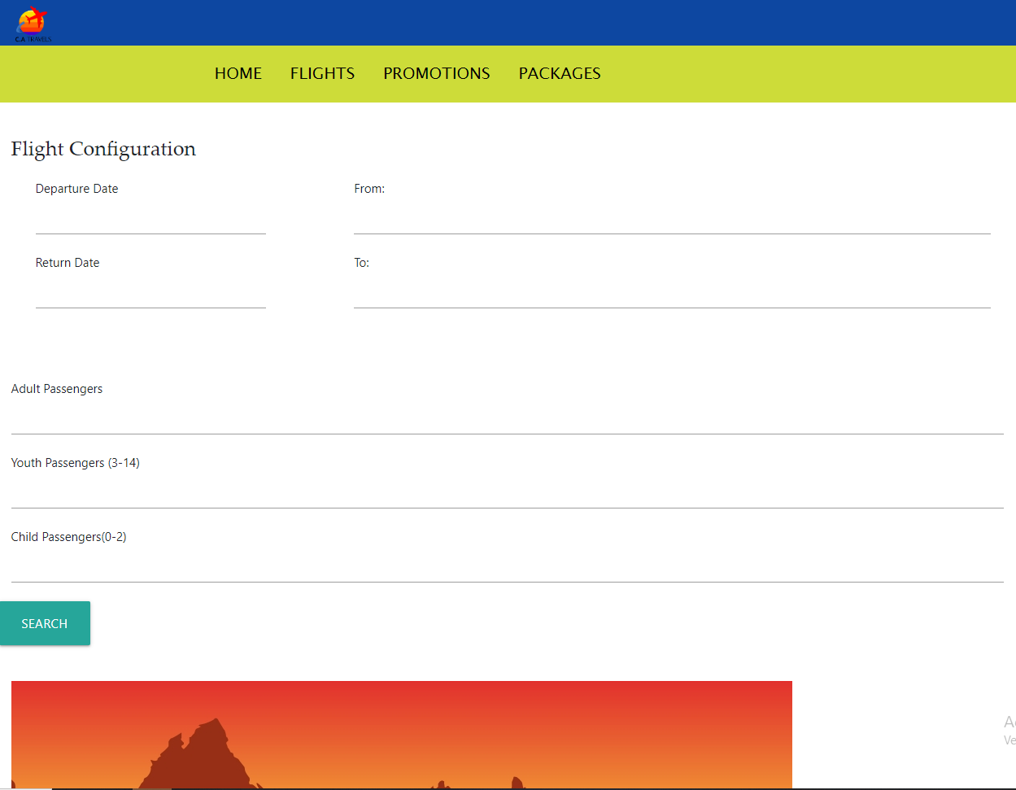

After selecting one country to travel to, the user will be redirected to this page, where it will ask specific information about the flight.

It will require, departure date, return date, from which city, to which city in central America; how many adult passengers, how many youth passengers and how many child passengers.

**Promotions part 1**

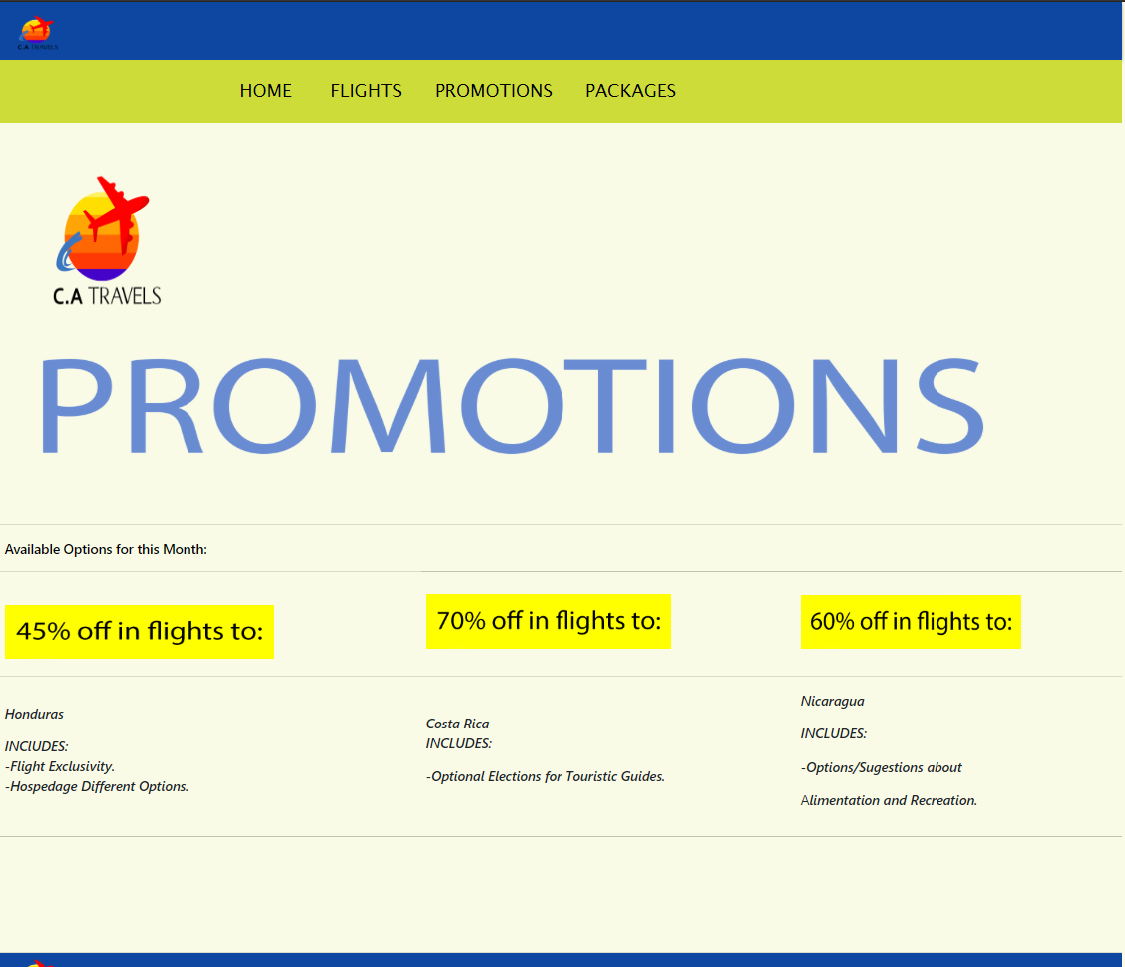

When the user enters here, 3 options will appear giving ideal deals for specific flights to the shown country, the user will have to click on the yellow boxes to proceed to the payment section and finish the process of buying a discounted flight.

However, the options will only change after certain time and payments have been done by the user.

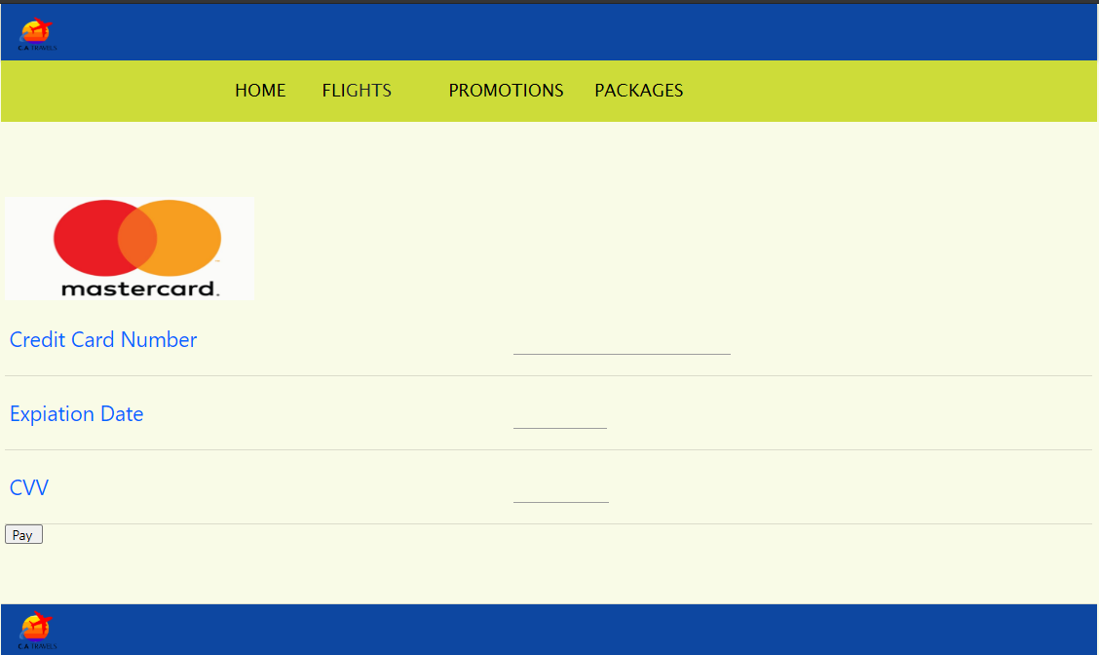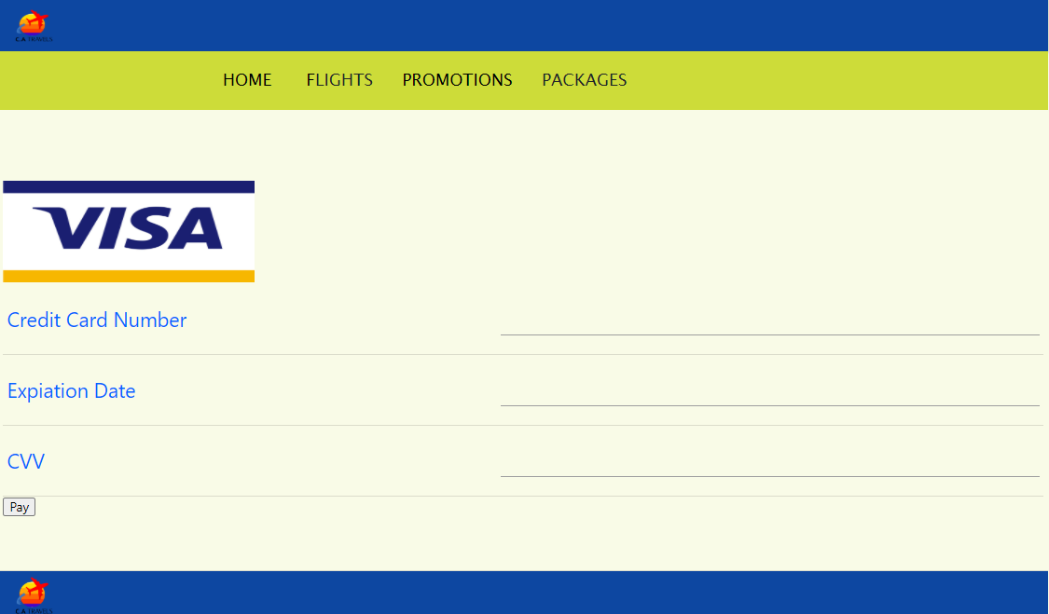**Promotions part 2, payment**

After the user has selected one ideal offer, the website will redirect it to one of this page to fill all the requested information with the data provided by our desktop application, then the user clicks the pay button to received the flight ticket by the email previously given.

**Package part 1**

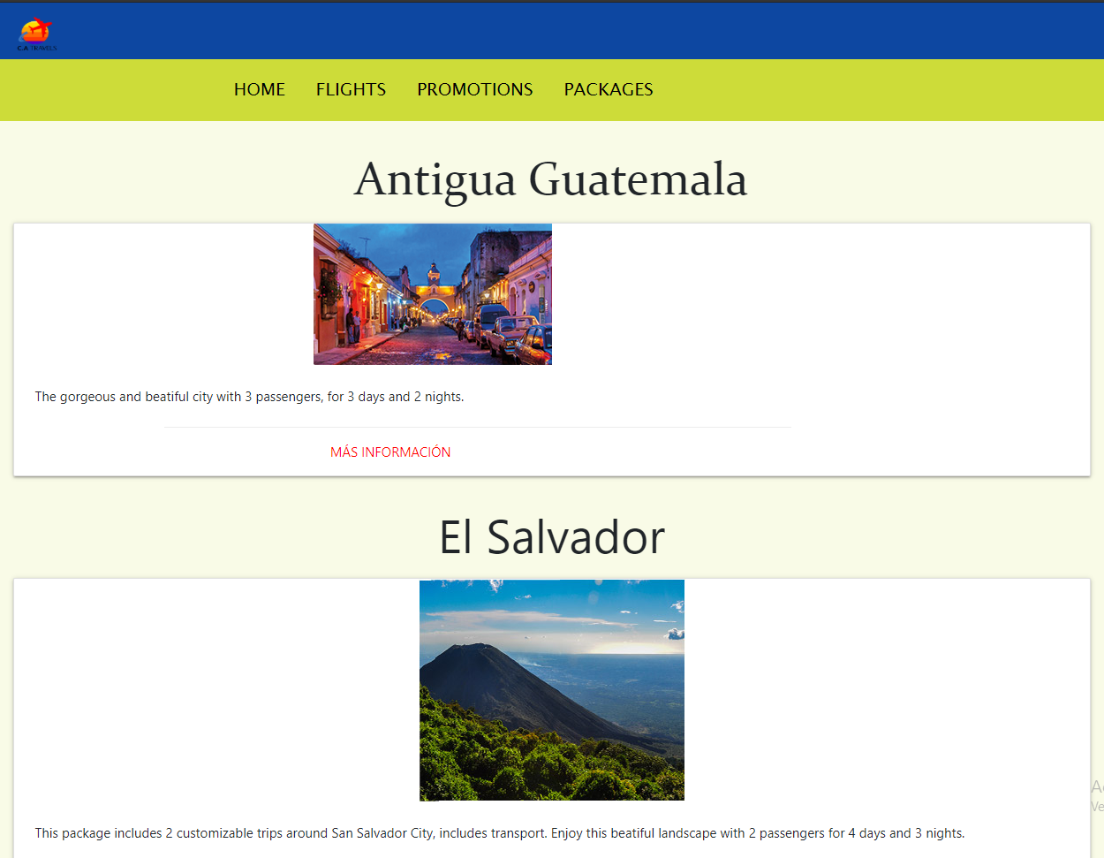

This section of the website has the purpose to help the user to have already payed everything to the user´s trip without searching in different pages, it has the five countries as options to the user so it can select the country that the user is interested the most, and after being redirected to a new section, the user will see if it’s convenient to pay.

Every country in this section has a very general information about what includes and how many days it will give until the returning flight.

**Package part 2, specific information**

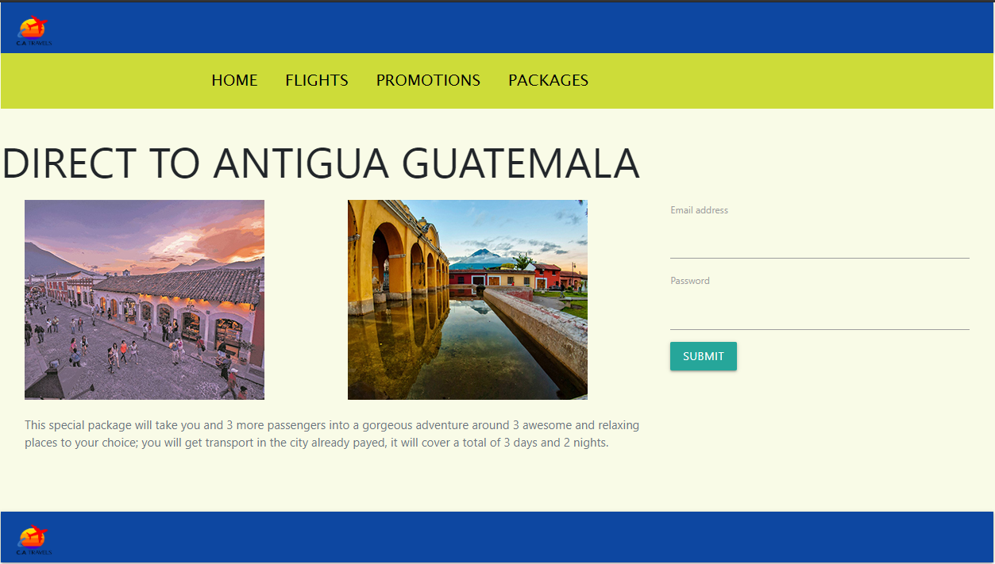

After the user chooses one of the countries, the website will redirect it to a page like this with more specific information, few images and at the right part, the formulary must be filled with the required information if the user wants to pay it.

Supposing that the user decides to pay it, it will redirect it to the same pages in “**Promotions part 2, payment”,** and the instructions are the same.

Administrator’s Guide

**INDEX**

**Introduction………………………………………….………page 2**

**Web page requirement……………………………………page 3**

**Enter the administrator page………………………..……page 4**

**admin registration…………………………………….….…page 5**

**what an administrator must fill………………………….…page 6**

Administrator’s Guide

Introduction

the administrator guide has the objective of systematically explaining the function that an administrator can have within the application, at the same time understanding how it works and what can be modified as an administrator.

Administrator’s Guide

Web page requirement:

1. The website can run on the following browsers.

* Google Chrome.
* Microsoft Edge.
* Internet explorer.

1. The minimal screen size of 15.6 inches and resolution 1080 x 720

Administrator’s Guide



When starting the web page it will load the user login, at the bottom there are three options, which the administrator can choose between two to enter the main page, they are "register as a company" or "enter as a company", the first option is to create a new administrator.



Options for administrators

Administrator’s Guide

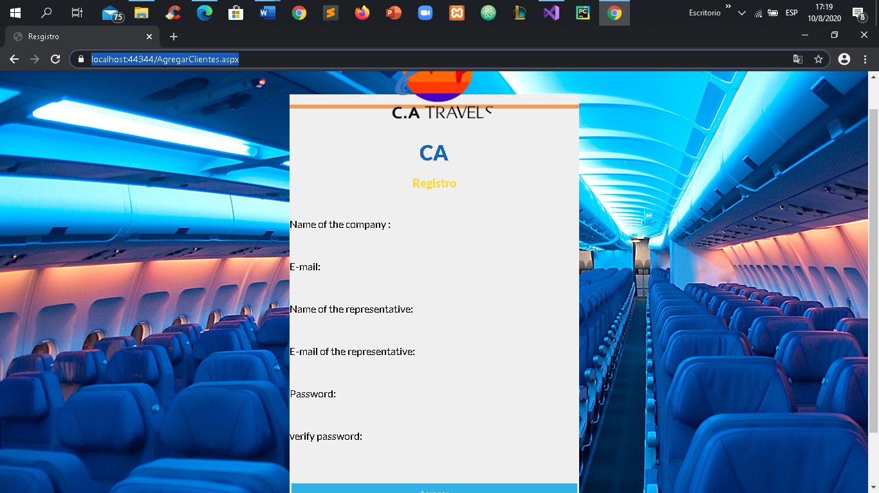

To register an administrator, the form must be filled out with basic information, to later fill out something more extensive and manage what can be seen on the page.

Administrator’s Guide

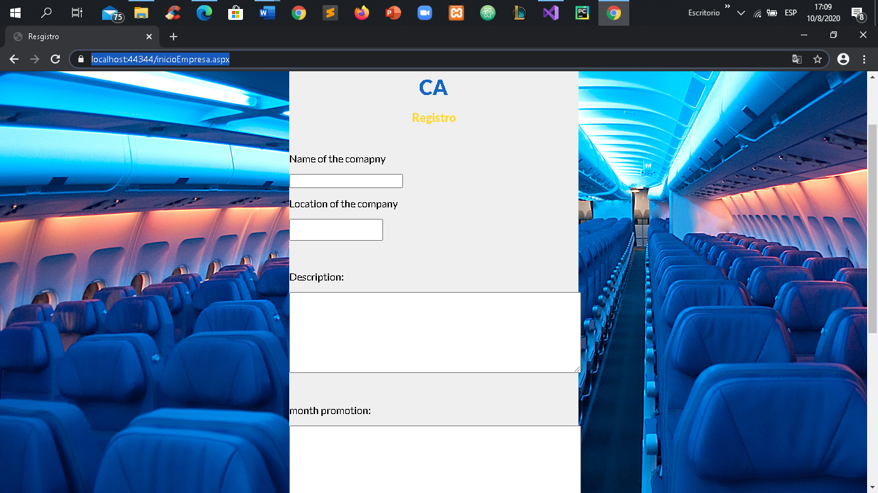

In this part the main information of the company is filled, which will be used to store and have the reference.

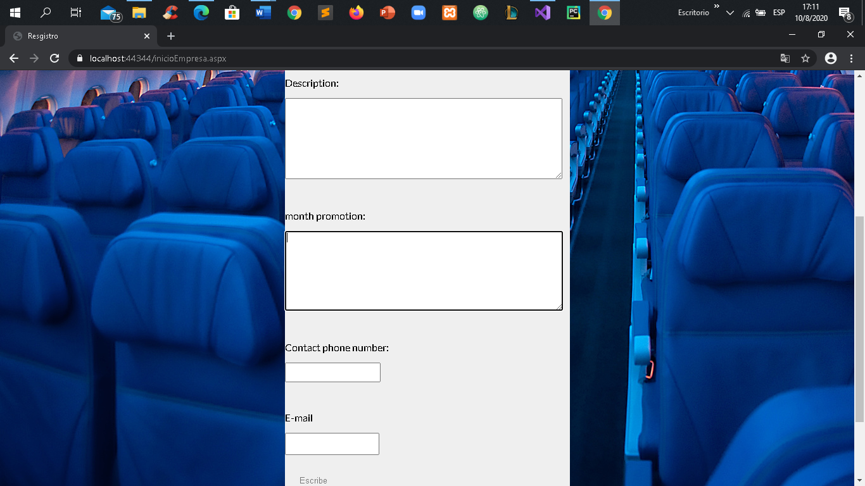

Here they will put the data that can be shown to the client. After creating all these fields, what has been put in each one will be shown on the main page for users.